Networking Essentials
Fourth Edition

Copyright © 2016 Pearson Education, Inc.
ISBN-10: 0-7897-5819-9
ISBN-13: 978-0-7897-5819-4
Warning and Disclaimer
Every effort has been made to make this book as complete and as accurate as possible, but no warranty or fitness is implied. The information provided is on an "as is" basis. The author and the publisher shall have neither liability nor responsibility to any person or entity with respect to any loss or damages arising from the information contained in this book or from the use of the CD or programs accompanying it.
When reviewing corrections, always check the print number of your book. Corrections are made to printed books with each subsequent printing.
First Printing: December 2015
Corrections for April 28, 2017
Pg | Error – Second Printing | Correction
8 | Chapter 1, Figure 1-2  Move Figure 1-4 to Figure 1-2 | Replace Figure 1-4 with Figure 1-2
10 | Chapter 1, Figure 1-2  Move Figure 1-2 to Figure 1-4 | Replace Figure 1-2 with Figure 1-4

Corrections for November 15, 2016
Pg | Error – Second Printing | Correction
34 | Chapter 1, Section 1-5, Replace Third Bullet | Replacement Bullet:  - Mac OS X: Click the Apple icon > System Preferences > Network. If you are connected:  - If you are connected, the Wi-Fi status will display “Connected” with green indicator.  - If the wireless Wi-Fi is on but is not connected to a network, the Wi-Fi status will display “On” with amber indicator.  - If the Wi-Fi is off, the Wi-Fi status will display “Off” with red indicator.
34 | Chapter 1, Section 1-5, Replace Last Bullet | Replacement Bullet:  Mac OS X: Click the Apple icon > System Preferences > Network, select the Wi-Fi connection then click the Turn Wi-Fi On button. The available wireless networks will appear under the Network Name drop down menu. Select a desired wireless network and enter password for WEP/WPA/WPA2 when prompted. If connected, a radio wave should now appear at the top of the screen in the menu bar, which indicates the network is connected.
45 | Chapter 1, Section 1-6, Replace Last Bullet | Replacement Bullet:  - Mac OS X: Click the Apple icon > System Preferences > Network and select the Ethernet or USB Ethernet connection. Under the Configure IPv4 drop down menu, select Manually. This option lets you manually set the IP address and subnet mask. Fields should now be displayed for inputting both the IP address and subnet mask. Enter the desired IP address and subnet mask, and select Apply.
191 | Chapter 4, Section 4-4, Replace Last Two Paragraph | Replacement Paragraphs:  The following is an example of setting up a Bluetooth network linking a Mac OS X computer to another Bluetooth-enabled device. To enable Bluetooth on the Mac OS X, click the Apple icon > System Preferences > Bluetooth and then click Turn Bluetooth On. The Mac will automatically discover other Bluetooth devices nearby.  In the next step you will select the device with which you will be establishing a Bluetooth connection. When Bluetooth is turned on, the Mac will search for another Bluetooth device. When a Bluetooth device is found, it will appear in the Devices window. To connect the desired Bluetooth device, select Pair button next to the device. This is called paring when another Bluetooth device is set up to connect to another Buetooth device. You will be asked for a Passkey. The Passkey is used in Bluetooth Security to limit outsider access to the pairing. Only people with the Passkey will be able to pair with your Bluetooth device.
192 | Chapter 4, Section 4-4, Replace Figure 4-18 | Replacement Figure:  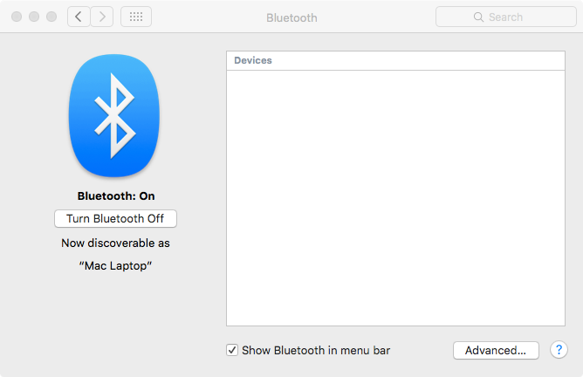
192 | Chapter 4, Section 4-4, Paragraph | Replacement Paragraph:  At this point, you are now able to transfer files between the paired devices. This requires that the Bluetooth Sharing settings for the device have been set to allow files to come in. Click the Apple icon > System Preferences > Sharing and select Bluetooth Sharing. Figure 4-19 shows an example of the setup for the file transfer.
192 | Chapter 4, Section 4-4, Replace Figure 4-19 | Replacement Figure:  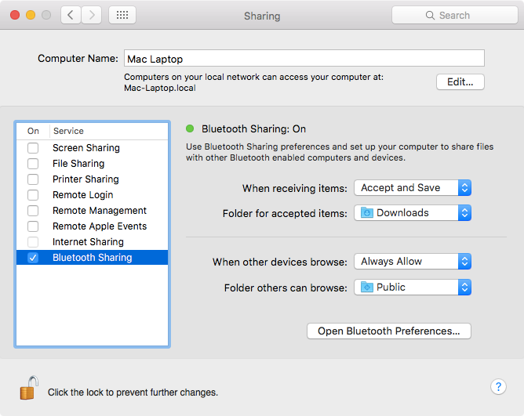
193 | Chapter 4, Section 4-4, Replace First Paragraph | Replacement Paragraph:  The screen shown in Figure 4-20 shows an incoming text file. The File Transfer menu enables the user to select where received files are saved. In this case, the incoming files are being saved to the desktop.

193 | Chapter 4, Section 4-4, Replace Figure 4-20 | Replacement Figure:  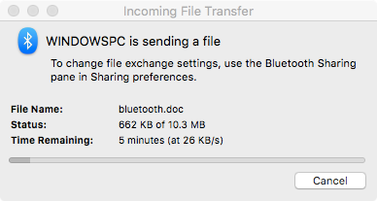
568 | Chapter 12, Section 12-4, Personal Firewall, Second Paragraph, Replace Last Three Sentences | Replacement Sentences:  The recent Mac OS X is deploying PF (Packet Filter) as its OS firewall. PF is a BSD-based stateful packet filter firewall. The following examples demonstrate how to configure firewall settings for Windows 7, XP, Mac OS X, and Linux.
572 | Chapter 12, Section 12-4, Mac OS X, Replace Sentence, Step 1 and Step 2 | Replace with:  To start the Mac OS X firewall configuration, use the following steps:  - Go to System Preferences and select Security & Privacy.  - In the Security & Privacy window, select Firewall. The firewall window displays the status of the firewall and lets you turn off the firewall as shown in Figure 12-15.

572 | Chapter 12, Section 12-4, Replace Figure 12-15 | Replacement Figure:  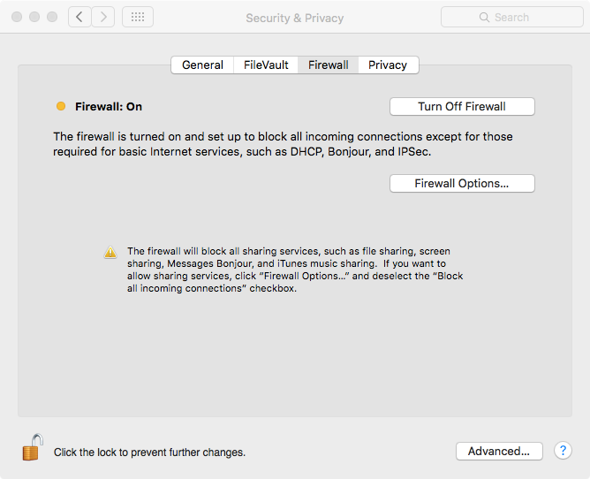
573 | Chapter 12, Section 12-4, Replace First Sentence in Step 3 | Replacement Step:  - Click Firewall Options button to open another window for more advanced settings, as shown in Figure 12-16. The firewall options are
73 | Chapter 12, Section 12-4, Replace Figure 12-16 | 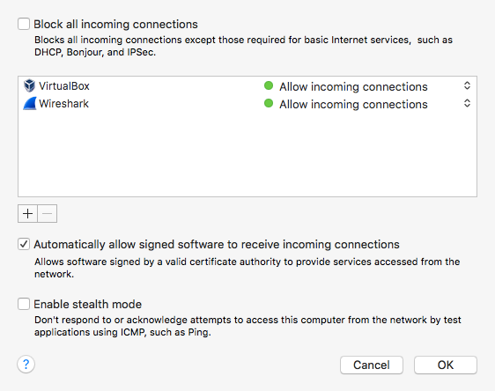
584 | Chapter 12, Section 12-5, Mac OS X – VPN Client, Replace First Two Paragraphs | Replacement Paragraph:  Mac OS X-VPN Client  - Click the Apple icon > System Preferences > Network and then click the plus sign to create a new service.  - A new window will appear. Select VPN as the new interface.  - Select the appropriate VPN type depending on the server configuration. The VPN type options are L2TP over IPSec, PPTP, Cisco IPSec or IKEv2.  - Leave the service name as default or select a new name, then click Create to create a new VPN service.  - Next, select Apply to save the configuration.  After completing the VPN setup, VPN connections can be established by selecting the VPN service under the System Preferences > Network window and click Connect button. You can also establish the VPN connection by clicking the VPN icon at the top of your Mac OS X main screen.

Corrections for June 7, 2016
Pg | Error – First Printing | Correction
18 | Chapter 1, Table 1-3, Third Row Down  Reads:  PAD A field used to bring the total number of bytes up to the minimum of 46 if the data field is less than 46 bytes. | Should read:  PAD A field used to bring the total number of bytes up to the minimum of 64 if the data field is less than 64 bytes.
32 | Chapter 1, Figure 1-23, Caption  Reads:  FIGURE 1-23 Linksys ADSL2 Modem (courtesy of Linksys). | Should read:  Figure 1-23 D-Link ADSL2 Modem (courtesy of D-Link).

Corrections for April 4, 2016
Pg | Error – First Printing | Correction
311 | Chapter 6, Questions and Problems, Section 6-5, Question 45, First Row under header  Reads:  # Mask Bits Subnet Mask # Subnets # Host/Subnet  2 | Should Read:  # Mask Bits Subnet Mask # Subnets # Host/Subnet  2 255.255.255.192 2 62

311 | Chapter 6, Questions and Problems, Section 6-6, Question 46, Third Column  Reads:  Classless  Interdomain  Routing (CIDR)  /30 | Should read:  Classless  Interdomain  Routing (CIDR)  /30  /25  /28  /26  /13  /20  /28  /27  /21  /14  /29  /30  /29

Corrections for February 3, 2016
Pg | Error | Correction
8 | Chapter 1, Figure 1-2  Replace | Replacement Figure:  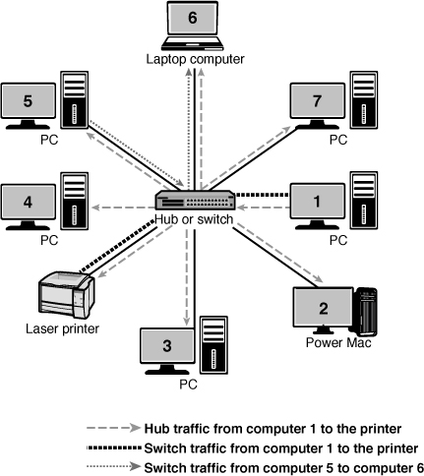
This errata sheet is intended to provide updated technical information. Spelling and grammar misprints are updated during the reprint process, but are not listed on this errata sheet.

