CCNA 200-301 Official Cert Guide and Network Simulator Library, Second Edition

Copyright © 2024 Pearson Education, Inc.
ISBN-10: 0-13-537138-4
ISBN-13: 978-0-13-537138-1
Warning and Disclaimer
Every effort has been made to make this book as complete and as accurate as possible, but no warranty or fitness is implied. The information provided is on an "as is" basis. The author and the publisher shall have neither liability nor responsibility to any person or entity with respect to any loss or damages arising from the information contained in this book or from the use of the CD or programs accompanying it.
When reviewing corrections, always check the print number of your book. Corrections are made to printed books with each subsequent printing.

To make best use of this table:
- Search for the printing number of your book.
- Ignore all entries listed for a lower numbered (older) printing.
- Use all entries listed for an equal or higher numbered (more recent) printing.
- To make a custom list for your printing:
  - Select the rows for printings older (lower numbered) than yours, and delete those rows
  - Select all remaining rows
  - Use the Table…Sort option to sort the table by page number

Volume 1

Page | Print | Correction
202 | 4 | 4th paragraph, 2nd line – change “switches did support” to “switches did not support”
214 | 4 | Example 8-11 – output from show vlan brief – the “act/lshut” and “active” text should be swapped on the lines for VLANs 10 and 20. Make the same swap for the lines for VLANs 30 and 40. That is, VLANs 10 and 30 are active, 20 and 40 are not.
273 | 4 | 3rd paragraph replace spanning-tree portfast default with spanning-tree portfast bpduguard default
275 | 4 | The global commands for portfast, BPDU Guard, and BPDU Filter use keyword default at the end rather than enable. Make these fixes at the top of the page:  - 1st paragraph – in the two bold commands, change “enable” to “default”  - 2nd paragraph – in the two bold commands, change “enable” to “default”  - Example 10-12 – 1st line – end of line - change “enable” to “default”
293 | 4 | 7th command in the table – replace spanning-tree portfast enable with spanning-tree portfast default
430 | 3 | Answer list at the bottom of the page – Should list question 4’s answers as “B, D”.
794 | 3 | Same change as page 430 for Chapter 17, Question 4’s answer letters.
10 | 1 | Figure 7 shows CCNA Volume 2 Premium Edition with additional CCNA exams 5-8. The product includes CCNA exams 5 and 6, but not 7 and 8.  Correct Figure 7:  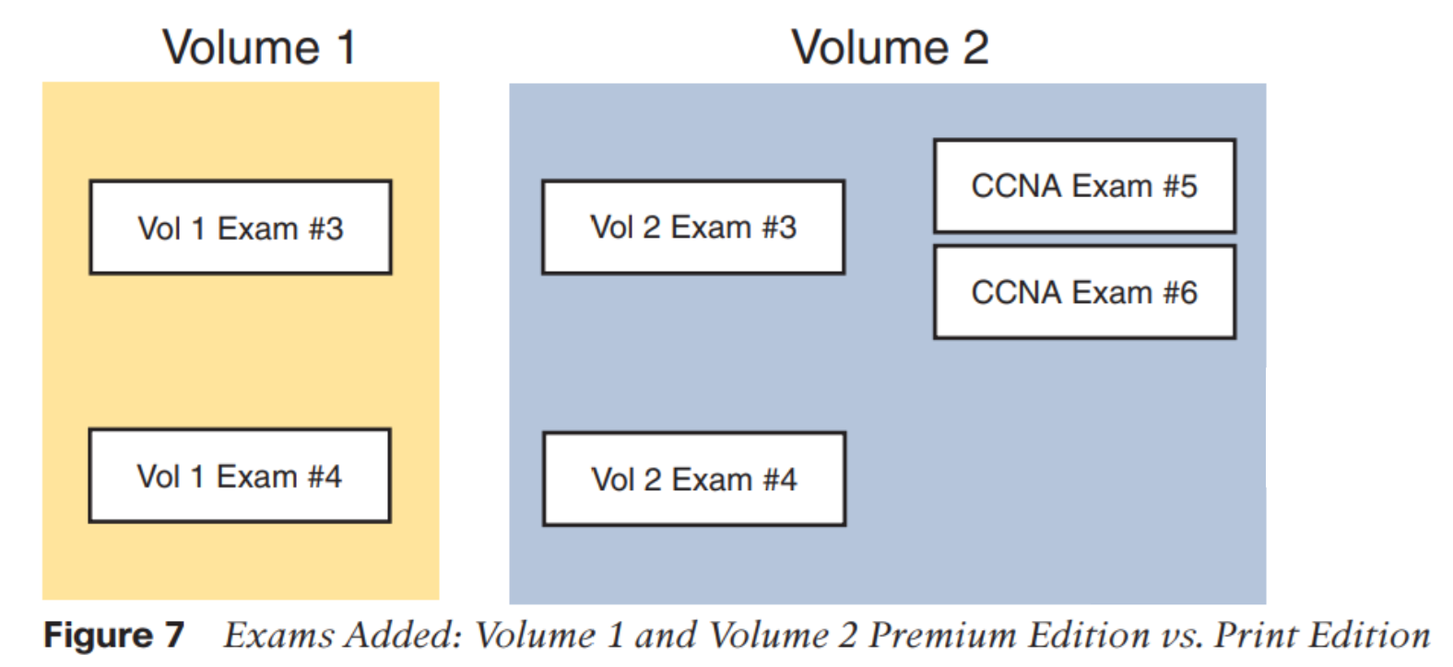
146 | 1 | Change username command parameter priority (incorrect) to privilege (correct) in the 4th bullet list item and twice in the 2nd-to-last paragraph on the page.
171 | 1 | Example 7-7 – 1st line – Insert show before running-config.
194 | 1 | 2nd-to-last paragraph, 5th line, “212” should be “2¹²”.
293 | 1 | Table 10-7, 7th command on this page, change spanning-tree portfast enable to spanning-tree portfast default
327 | 1 | Figure 12-3 – “Need 20 Public” – change “20” to “10”.
698 | 1 | Question 7, answer a, change ff02:1:2 to ff02::1:2.

Volume 2

Page | Print | Correction
57 | 2 | Chapter 4, question 1, change the question to: ‘Suppose you need to connect a Cisco AP to a network. Assume that the AP will be using split-MAC architecture. Which one of the following link types would be necessary?’
326 | 2 | Chapter 15, question 5, the letter answers should be “B, D”
337 | 2 | 1st line of paragraph just above the bullet list – RFC 4954 should be 4594.
630 | 2 | Chapter 15, question 5, the letter answers should be “B, D”
221 | 1 | Table 10-3 – bottom-right cell – change “SHA-256” to “Scrypt”.

